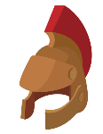
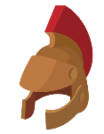
HISTORY
EYFS LEARNING IN
KNOWLEDGE ORGANISER
Overview |  |  |  |  | Understanding the World – The World |  |  | Key Vocabulary  History  Past  Present  Future  Time  Family  Friends  Earth  Community  Environment
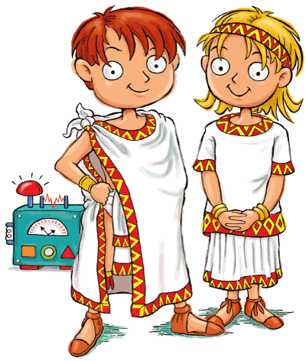  History  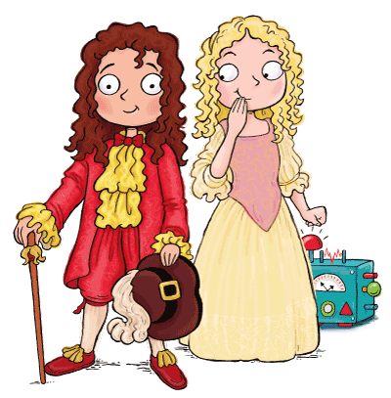  -In History, we look at things that have happened in the past.  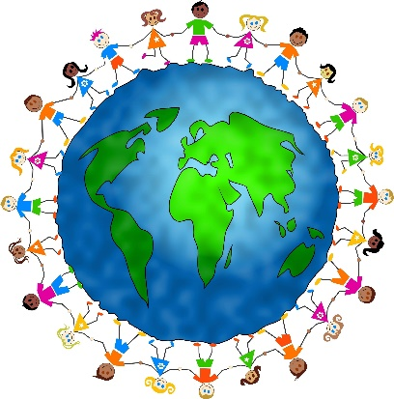  We look at the things humans have done in the past, to try and help us understand the present, and what may happen in the future.  In EYFS, we learn about the past and present through looking at our lives and the lives of family and friends.  Almost all of the early History learning can be found in ‘Understanding the World’, one of the 7 learning areas. |  |  |  |  | 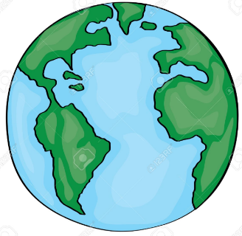  Our World  -Our world is a planet called Earth. It is one of a number of planets that go around the Sun.  -On Earth, there are many different countries. In each country, there are cities, towns and villages.  -Which country do you live in? Which town/city?  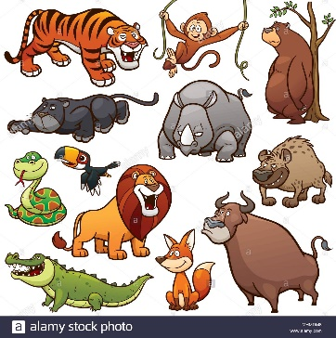  Nature and Objects  -Humans share the planet with lots of other living things, including plants and animals.  -Animals and plants live in many different ways.  -There are also things that people have made in the world, for example buildings and cars.  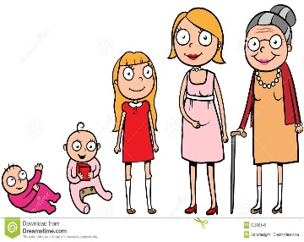  Changes over Time  -Humans go through life stages: baby, toddler, child, teenager, adult and old people.  -Other things change over time too. For example, they can grow, shrink, decay and die.
Understanding the World – People and Communities
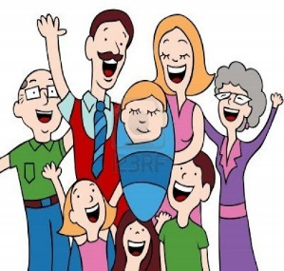 | Family and Friends  Sub-Area: People and Communities | -Family are people who are related to one another.  -Friends are people who like spending time together.  Family members include:  Mother/Mum Father/Dad Parent Sister Brother Grandmother/Nana Grandfather/Papa Auntie  Stepmother/father/sister/brother Uncle Cousin
 | Family and Friends  Sub-Area: People and Communities |  |  |  | Extended Learning
 |  |  |  |  | 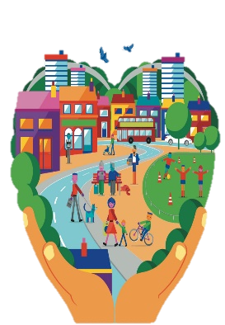 | Communities & Traditions  Sub-Area: People and Communities | -A community is a group of people who live in a particular place or have something in common.  -E.g. all of the teachers, parents and children at your school make up your school community.  -Your town or village is your local community.  -A tradition is something that people in a group or community do, that has been passed down over time.  -E.g. eating certain foods, wearing certain clothes.
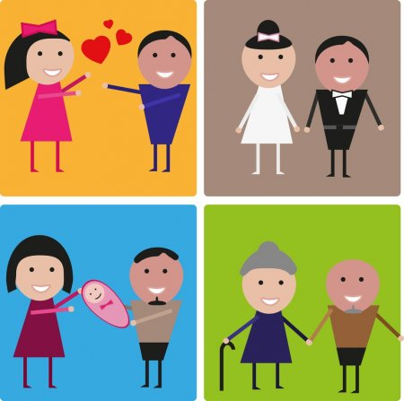 | Experiences  Sub-Area: People and Communities | -An experience is something that happens to us in our lives. Important experiences are called life events.  Life events may include:  -Birthday -Starting school -Birth of brother/sister  -Wedding -Christening -Achievements/ success! |  |  |  | Communities & Traditions  Sub-Area: People and Communities
 | Experiences  Sub-Area: People and Communities |  |  |  | 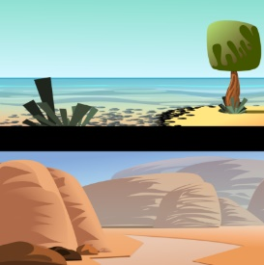 | Environments  Sub-Area: The World | -Environments are our surroundings.  -Different people, plants and animals like to live in different environments.  -Some examples of natural environments are: garden, forest, beach, desert, rainforest, polar or mountain.
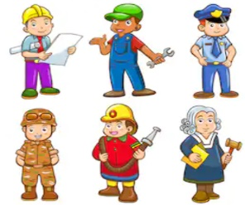 | Ways of Life & Occupations  Sub-Area: People and Communities | -We share some things with other people. Some things make us unique (different to everyone else).  -A way of life is how you choose to spend your time.  -An occupation is a job – what you do for work.  -Occupations include: teacher, policeman, chef, etc. |  |  |  | Environments  Sub-Area: The World

THE FUTURE: What I will do when I am an old person
THE FUTURE: What I will do when I am a grown up
THE FUTURE: What I will do next week
THE FUTURE: What I will do later today
-THE PAST: What I did earlier today
-THE PAST: What I did last week
-THE PAST: When I was a baby
-THE PAST: Birth of parents
-THE PRESENT: What I am doing right now
-THE PAST: Birth of grandparents
Time and Chronology

