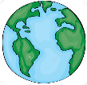
GEOGRAPHY
EYFS LEARNING IN
KNOWLEDGE ORGANISER
Overview |  |  |  |  | Understanding the World |  |  | Key Vocabulary  The World  Earth  People/ Humans  Animals  Plants  Nature  Man-made  Environment  Community  Tradition
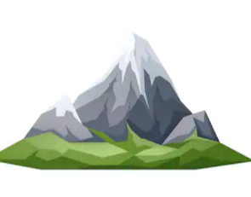  Geography  -In Geography, we learn about the Earth and its people.    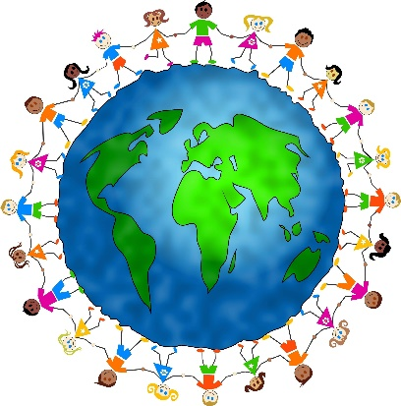  -We look at the different natural things that are found on Earth, for example rivers and mountains.  -We also look at how people live in different parts of the world.  In EYFS, we learn about the world and the people around us, (our ‘familiar world’)  Almost all of the early Geography learning can be found in ‘Understanding the World’, one of the 7 learning areas. |  |  |  |  | 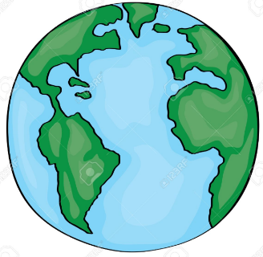  Our World  -Our world is a planet called Earth. It is one of a number of planets that go around the Sun.  -On Earth, there are many different countries. In each country, there are cities, towns and villages.  -Which country do you live in? Which town/city?  Natural and Man-Made  -Humans share the planet with lots of other things, including plants and animals, mountains, rivers, and oceans. None of these things are made by people. They are a part of nature – they are natural.  -There are also things that people have made in the world (man-made), Examples include buildings, cars, benches, tables, televisions, and toys!  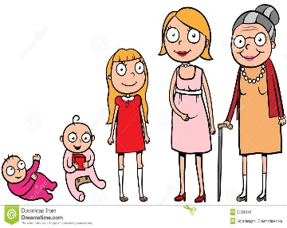  Changes over Time  -Humans go through life stages: baby, toddler, child, teenager, adult and old people.  -Other things change over time too. For example, they can grow, shrink, decay and die.
Understanding the World
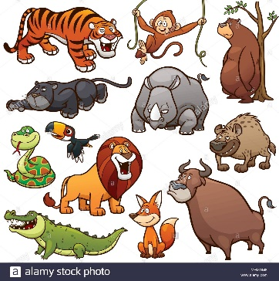 | Living Things - Animals  Sub-Area: The World | -Animals are living things.  -Animals get their food by eating plants or other animals. Animals can be big like elephants, or small like mice. We humans are animals!  Some animals you may see around you  Cats Dogs Rabbits Lizards Bees Flies Cows Horses Sheep Pigs Goats  Chickens Pigeons Worms Beetles Badgers
 | Living Things - Animals  Sub-Area: The World |  |  |  | Extended Learning
 |  |  |  |  | 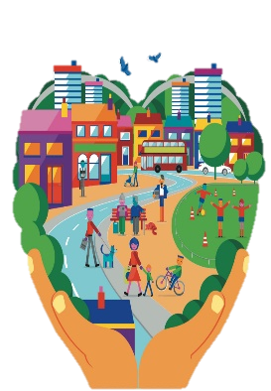 | Communities & Traditions  Sub-Area: People and Communities | -A community is a group of people who live in a particular place or have something in common.  -E.g. all of the teachers, parents and children at your school make up your school community.  -Your town or village is your local community.  -A tradition is something that people in a group or community do, that has been passed down over time.  -E.g. eating certain foods, wearing certain clothes.
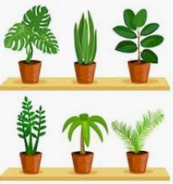 | Living Things - Plants  Sub-Area: The World | -Plants are also living things.  -Most plants do not eat other plants or animals for food. Plants can be big like trees, or small like weeds.  Some plants that you may see around you:  -Grass -Weeds -Trees -Bushes  -Flowers -Stinging Nettles -Dandelions -Daisies |  |  |  | Communities & Traditions  Sub-Area: People and Communities
 | Living Things - Plants  Sub-Area: The World |  |  |  | 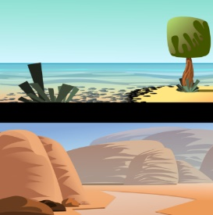 | Environments  Sub-Area: The World | -Environments are our surroundings.  -Different people, plants and animals like to live in different environments.  -Some examples of natural environments are: garden, forest, beach, desert, rainforest, polar or mountain.
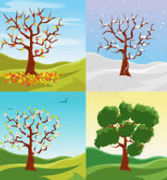 | The Seasons -  Sub-Area: The World | -The weather changes at different times in the year.  -The four seasons are winter, spring, summer and autumn. It is coldest in the winter and warm in summer.  -We can see different plants and animals in the different seasons. |  |  |  | Environments  Sub-Area: The World

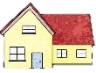
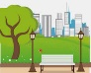

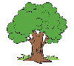
My House
Hills and Mountains
The Park
The Beach
The River
The Village/ Town/ City
School Playground
My School
My Garden
The Forest
Local Environments

