
“We didn’t know we were making memories, we just knew we were having fun.” Winnie the Pooh

Hello fellow parents

Over this term, and through the sheer hard work of the PTA, teachers and of you parents, we have raised £6,447.81 for the school.

Funds were raised from from the following events and funders:
- Grandparents afternoon
- Summer Fete
- Rainbow Bolt
- Easy Fundraising
- Friends of St Leonard’s (those supporting with a monthly donation)*
- A big thank you to our Rainbow Bolt fundraisers too - Zack, Holly, Ben, Asher, Rory, Elliott, Grace and Elizabeth.

All of this has required a great deal of effort from the PTA and the school staff who have volunteered their time to run these activities.

We will spend funds raised on a number of resources and activities that all of the children benefit from, including:
- The Community Garden
- Nurture Room Fund
- Spiritual and Nature garden space
- Swimming coaches
- Fans for classrooms
- Classroom resources

Thank you for all of your support over this term, and thank you to everyone who has already responded to our Friends of St. Leonard’s Campaign to help raise funds over the coming year for new resources for the children.

And to those families moving on next term to middle school, thank you for all of your support over the past five years. We hope you will continue to join us at events like the fireworks display, Christmas Fayre and Summer fete. To keep in touch please email pta@stleonardslower.co.uk to be added to our new event mailing list. Though we may no longer be your school, we hope you will continue to be part of our community.

Wishing you and your families a very happy summer holiday.

Best wishes
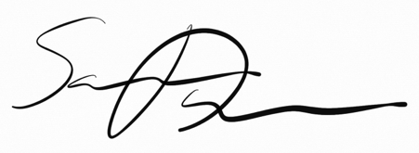

Samuel Davies, PTA Treasurer
Samuelajdavies@gmail.com
Our PTA is a registered charity. No.1101801

* For those who haven’t already done so, you can become a Friend of St Leonard’s by setting up your regular donation here: localgiving.org/stleonardsvaschool. Funds from this group are a stable form of fundraising that enable us to invest in new school materials and costs relating to PTA events.

