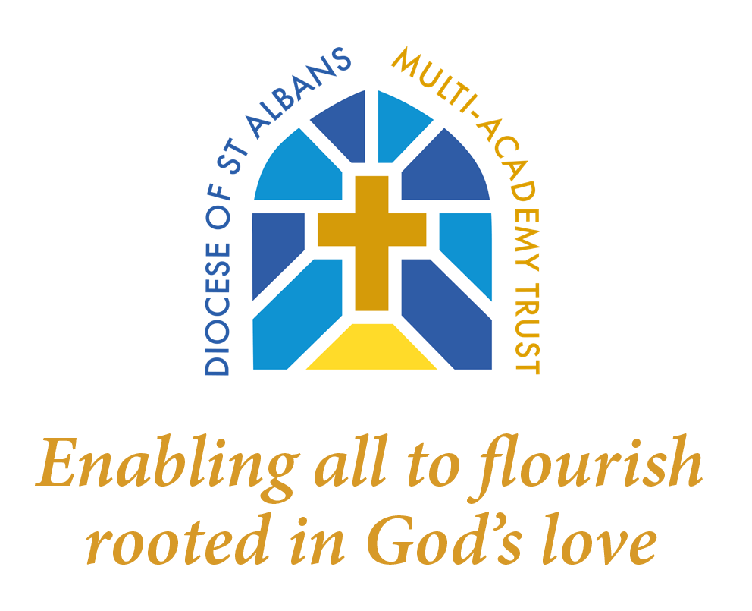
Trust Religious Education Policy

Policy type | Trust wide with local context (based on the Diocese model policy)
Review | Annually
Author/Responsible Officer | Christian Distinctiveness Lead
Approved by | Trust Senior Leaders
Date of ratification | April 2026
Date of next review | April 2029
This policy is a mandatory policy for all DSAMAT Academies and must be implemented with localised amendments

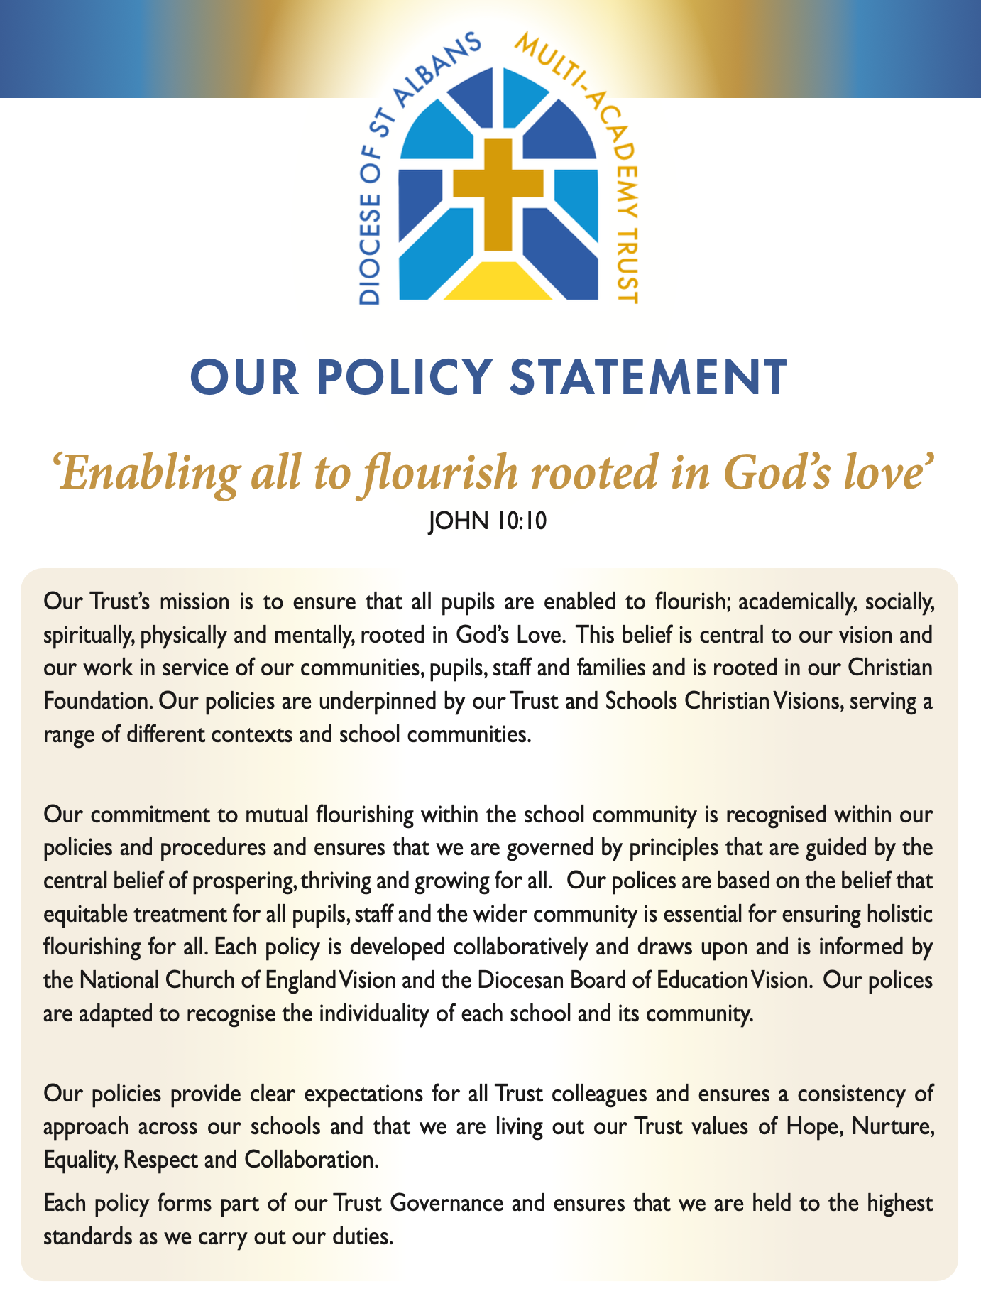
This document is a model policy – please feel free to draw on the language used to create a bespoke school policy which reflects the school’s context, vision and associated practice.

Add here the school’s distinctive Christian vision and a briefly explain how religious education (its aims, planning, curriculum design etc.) is an expression of the school’s vision.

RE Policy Statement

Religious education is unique in the curriculum in that it is neither a core subject nor a foundation subject but the 1988 Education Act states that: ‘Religious Education has equal standing in relation to core subjects of the National Curriculum in that it is compulsory for all registered pupils’.

Aims

The broad aims of religious education are set out within [the locally agreed syllabus and] the Church of England Education Office Statement of Entitlement (2026). The primary purpose of religious education is to promote religious literacy. By this we mean that pupils are able to hold balanced and well-informed conversations about religion and belief.

The aims of RE are to enable pupils to:
• Know about and understand Christianity as a diverse global living faith through the exploration of core beliefs using an approach that critically engages with biblical text;
• To gain knowledge and understanding of a range of religions and worldviews, appreciating diversity, continuity and change within the religions and worldviews studied;
• To engage with challenging questions of meaning and purpose raised by human experience and existence;
• To recognise the concept of religion and its continuing influence on Britain’s cultural heritage and in the lives of individuals and societies in different times, cultures and places; and
• To explore their own religious, spiritual and philosophical ways of living, believing and thinking.

In achieving these aims, religious education contributes in a significant way to the flourishing of all children, allowing them to live life in all its fullness (John 10:10).

As an academy, RE is taught in accordance with our funding agreement.

Curriculum

Religious education is an academic subject, delivered in an academic, objective and pluralistic manner.

The curriculum for religious education is designed to ensure religious literacy lies at the heart. A multi-disciplinary approach to curriculum design provides a balance between theology, philosophy and the human/social sciences.

Theology: This examines where beliefs come from, how they have changed over time, how they are applied differently in different contexts and how they relate to each other.

Philosophy: This is about finding out how and whether things make sense. It deals with questions of morality and ethics. It takes seriously questions about reality, knowledge and existence.

Human/Social Sciences: This explores the diverse ways in which people practice their beliefs, both now and in the past. It engages with the impact of beliefs on individuals, communities and societies.

A sequential curriculum map has been designed in order to allow pupils to become religiously literate through developing, year on year, their knowledge and skills. The three disciplines detailed above provide lenses through which each enquiry question is approached.

• At Key Stage One, pupils study… [pupils study e.g. primarily Christianity and Judaism, with reference made to other principal religions, beliefs and worldviews].

• At Key Stage Two pupils study… [e.g. primarily Christianity, Islam and Hinduism, with reference made to other principal religions, beliefs and worldview].

In accordance with the Statement of Entitlement (2026), at least 50% of curriculum time is allocated to the teaching of Christianity. This entitlement is met both through the weekly or blocked teaching of religious education, and through additional ‘RE’ days which focus on an aspect of the Christian Faith.

The use of the resource Understanding Christianity particularly supports the development of the theological perspective.

Teaching RE

Religious education uses an enquiry-based approach to learning. This is based on the best practice framework in [Understanding Christianity/the Bedfordshire/Hertfordshire/Barnet/Buckinghamshire Agreed Syllabus]. This approach enables pupils to focus on an enquiry question which explores aspects of the theological, philosophical and human/social sciences. A range of teaching strategies are used to ensure learning is challenging and relevant including the use of art, music, thinking skills, artefacts and stories.

Where possible we want our pupils to have opportunities to encounter local faith communities through visits to local places of worship or visit from members of local faith communities.
Assessment

Pupils are assessed in terms of how they are making progress in relation to the theological, philosophical and human/social sciences disciplines within religious education. In broad terms, the following principles have been applied to each aspect in terms of what it means to become more religiously literate:
• Extending knowledge and understanding from the concrete and familiar to the abstract and complex;
• Moving from simple ideas and beliefs/concepts to making connections between them and placing these within a bigger picture or meta-narrative;
• Demonstrating increasing layers of interpretation of religion, religions, beliefs and worldviews through engagement with a broadening and increasingly complex range of information;
• Showing an increasing ability to critically question and form coherent, logical arguments, including increasing recognition of divergences of opinion about and the controversial nature of religion and belief; and
• Expressing a broadening understanding of diversity in terms of the nature of religion, religions and worldviews.

Pupils are assessed using age-related expectations. This is done in a variety of ways e.g. through written activities, role play, art work, discussion. [Progress is tracked using…].

Assessment is regarded as an integral part of teaching and learning and is a continuous process. It is the responsibility of the class teacher to assess all pupils in their class. We assess the children in order to ensure that they make good progress in this subject and to plan future work.

In addition, pupils are encouraged to use self-assessment to evaluate their own knowledge and understanding. A comment about their progress is made in the annual report to parents.

Monitoring and Evaluation

The co-ordinator will monitor provision and standards within the school through observation, looking at work, talking to children and reviewing the curriculum with staff.

The co-ordinator is responsible for contributing to the school’s self-evaluation process. In addition, headteacher monitors the role of religious education in upholding the funding agreement of the trust and its contribution to the Christian vision of the school.

Responsibilities for RE within each school

As well as fulfilling their legal obligations, the headteacher should also make sure that:
• all pupils make progress in achieving the aims of the RE curriculum;
• the subject is well-led and effectively managed;
• standards and achievement in RE and the quality of the provision are subject to regular and effective self-evaluation;
• those teaching RE are suitably qualified and trained in the subject and have regular and effective opportunities for CPD;
• where appropriate, pupils have opportunities to take courses leading to an accredited qualification in the subject;
• clear information is provided on the school website about the RE curriculum;
• RE is resourced, staffed and timetabled so that the school can fulfil its legal obligations on RE and pupils can make good progress;
• where there are insufficient teachers in a school/academy who are prepared to teach RE, the principal/headteacher ensures that pupils receive their entitlement to religious education. In these circumstances, headteachers might wish to seek advice from the Diocese.

The Right of Withdrawal From RE

Our school is an inclusive community but recognises that parents have the legal right to withdraw their children from religious education on the grounds of conscience. However, the right of withdrawal does not extend to other areas of the curriculum when, as may happen on occasion, spontaneous questions on religious matters are raised by pupils or there are issues related to religion that arise in other subjects such as history or citizenship.

Managing the right of withdrawal
• The use of the right to withdraw should be at the instigation of parents, and it should be made clear whether it is from the whole of the subject or specific parts of it. No reasons need be given;
• Where parents have requested that their child is withdrawn, their right must be respected, and where religious education is integrated in the curriculum, the school will need to discuss the arrangements with the parents or carers to explore how the child’s withdrawal can be best accommodated;
• If pupils are withdrawn from religious education, the school has a duty to supervise them, though not to provide additional teaching or to incur extra cost. Pupils will usually remain on the premises;
• Where a pupil has been withdrawn, the law provides for alternative arrangements to be made for religious education of the kind the parent wants the pupil to receive. This religious education could be provided at the school in question, or the pupil could be sent to another school where suitable religious education is provided if this is reasonably convenient;
• If neither approach is practicable, outside arrangements can be made to provide the pupil with the kind of religious education that the parent wants, and the pupil may be withdrawn from the school for a reasonable period of time to allow them to attend this external religious education;
• Outside arrangements for RE are allowed as long as the local authority is satisfied that any interference with the pupil’s attendance at the school resulting from the withdrawal will affect only the start or end of a school session.

Role of the RE Leader
• To ensure that the RE policy is implemented and to keep up to date with reviews;
• To have oversight of the RE curriculum and keep up to date with local and national changes;
• To monitor, review and update resources;
• To monitor pupil progress and achievement;
• To maintain and build priorities set by the school;
• To develop links with the Church and Diocese;
• To coach, mentor and support teachers in developing their strengths in teaching RE, including planning, arranging and delivering CPD as appropriate; and
• To liaise with parents to ensure all children receive their entitlement.

Entitlement and Inclusion - EAL, SEN, More Able

All children are entitled to access a broad and balanced curriculum at an appropriate level. Teachers should include a range of teaching styles and groupings to allow all children to make progress. Every child should be given opportunity to develop their skills independently and in groups, enhancing their own confidence and self–esteem.

Parental and Community Involvement

Parents are encouraged to involve themselves in RE within each school. Parents are invited into the school to look at their children’s work, and a report on their child’s standard and progress in religious education is given out annually. The community is encouraged to support the teaching of the subject through visits and visitors, e.g.: the children visit the church to learn about concepts such as salvation.

Professional Development

Whole staff and individual training needs will be identified through the school ‘s self-evaluation process and staff appraisal.

The contribution RE makes to other curriculum aims

Spiritual, moral, social and cultural development

Section 78 (1) of the 2002 Education Act states that all pupils should follow a balanced and broadly based curriculum which ‘promotes the spiritual, moral, cultural, social, mental and physical development of pupils and of society, and prepares pupils for the opportunities, responsibilities and experiences of later life’. Examining and exploring religions and beliefs, through the distinct knowledge, understanding and skills contained in religious education, is essential to achieving these aims. Exploring the concepts of religion and belief and their roles in the spiritual, moral and cultural lives of people in a diverse society helps individuals develop moral awareness and social understanding.

Personal development and well-being

Religious education plays an important role in preparing pupils for adult life, employment and lifelong learning. It helps children and young people become successful learners, confident individuals and responsible citizens. It gives them the knowledge, skills and understanding to discern and value truth and goodness, strengthening their capacity for making moral judgements and for evaluating different types of commitment to make positive and healthy choices.

Community cohesion

Religious education makes an important contribution promoting community cohesion. It provides a key context to develop young people’s understanding and appreciation of diversity, to promote shared values and to challenge racism and discrimination. Effective religious education will promote community cohesion at each of these four levels.

The school community
Religious education provides a positive context within which the diversity of cultures, beliefs and values can be celebrated and explored.
The community within which the school is located
Religious education provides opportunities to investigate patterns of diversity of religion and belief and forge links with different groups in the local area.

The UK community
A major focus of religious education is the study of diversity of religion and belief in the UK and how this influences national life.

The global community
Religious education involves the study of matters of global significance recognising the diversity of religion and belief and its impact on world issues.

Religious education subject matter gives particular opportunities to promote an ethos of respect for others, challenge stereotypes and build understanding of other cultures and beliefs. This contributes to promoting a positive and inclusive academy ethos that champions democratic values and human rights.

Monitoring and Review

The implementation and impact of the policy will be evaluated through the school’s self-evaluation processes. The policy will be reviewed every three years.

