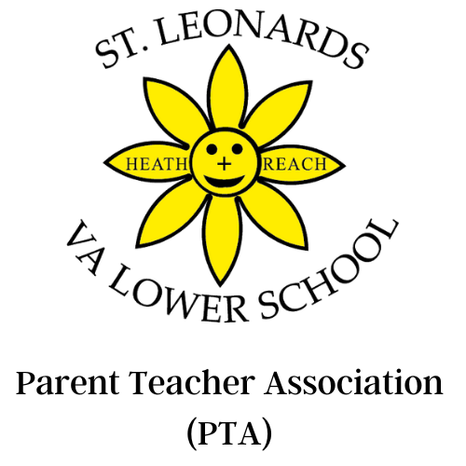

“We should all be proud, the teamwork over the last couple
of days is inspiring. We are showing our children what can
be achieved when we work together!”
– Laura Miles (The Summer Fete)

Hello fellow parents

Over this term, and through the sheer hard work of the PTA, teachers and of you parents, we have raised £6,984.72 for the school. This has been raised from the following fundraising events and funders:

- The Summer Fete
- The Quiz
- The Grandparents afternoon
- Break the Rules Day
- Friends of St Leonards
- School Disco
- Big Breakfast
- Giveasyoulive

All of this has required a great deal of effort from the PTA and the school staff who have volunteered their time to run these activities.

We will spend funds raised on a number of items that all of the children benefit from, including:

- Swimming coaches
- Classroom resources
- Enhanced school security and safety

Thank you for all of your support over this term and thank you to everyone who has already responded to our Friends of St. Leonard’s Campaign to help raise funds over the coming year for new resources for the children. If you haven’t already done so, you can become a Friend of St Leonard’s by setting up your regular donation here: localgiving.org/stleonardsvaschool

Wishing you and your families a wonderful Summer.

Best wishes


Samuel Davies, PTA Treasurer
Samuelajdavies@gmail.com
Our PTA is a registered charity. No.1101801

