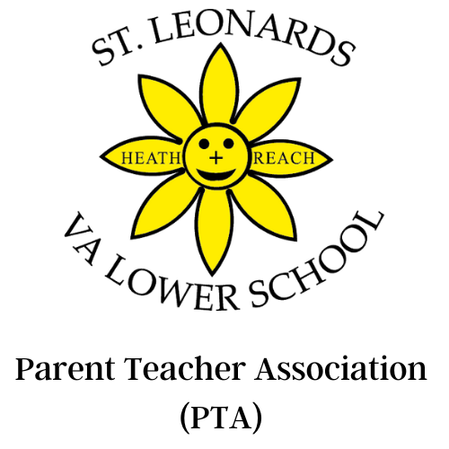

What makes a good friend?
“A good friend is kind, nice, and good, and helpful, and good to teachers” - Ben, yr.2
“A great friend is friendly, supportive and cheers them up and cheers them on.” - Amelie, yr.4
“Team work, helping tidy up cars, playing together, making each other happy.” - Asher, 4+

Hello fellow parents

Over this term, and through the sheer hard work of the PTA, teachers and of you parents, we have raised £5,510.92 for the school. This has been raised from from the following fundraising events and funders:
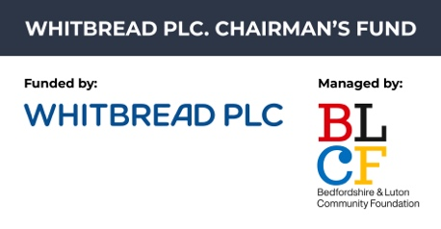
- The Big Breakfast
- The Quiz
- Easy Fundraising
- School Disco
- Whitbread PLC. Chairman’s Fund, in partnership between Bedfordshire and Luton Community Foundation (BLCF) and Whitbread Plc.

All of this has required a great deal of effort from the PTA and the school staff who have volunteered their time to run these activities.

We will spend funds raised on a number of resources and activities that all of the children benefit from, including:
- Swimming coaches
- Classroom resources
- Times Table Rockstar subscription
- New website
- Natre
- Sports locker and sports equipment

Thank you for all of your support over this term, and thank you to everyone who has already responded to our Friends of St. Leonard’s Campaign to help raise funds over the coming year for new resources for the children. If you haven’t already done so, you can become a Friend of St Leonard’s by setting up your regular donation here: localgiving.org/stleonardsvaschool

Wishing you and your families a very happy Easter break.

Best wishes
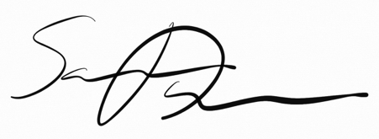

Samuel Davies, PTA Treasurer
Samuelajdavies@gmail.com
Our PTA is a registered charity. No.1101801

